Home Program: Mirror Therapy

The Basics | To get the best results, you should do these exercises every day.  Some people find it is better to practice twice a day for a shorter time.  Try to practice for 20 to 30 minutes every day.
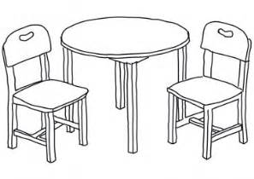 | Find a spot at a table that is a comfortable height to sit at with your arms on the table.  A quiet area where you can focus is best.
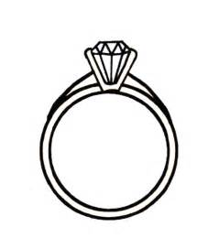 | You should take off any jewelry or watches from the ‘good’ hand

The basics | Remember that you are trying to change your brain! This might be slow, and the steps may be small. But if you practice, you will see changes.
Stop doing the mirror exercises if it makes you feel dizzy or seasick.
This doesn’t happen very often, but if it does, your therapist can give you other ways to work on your arm.

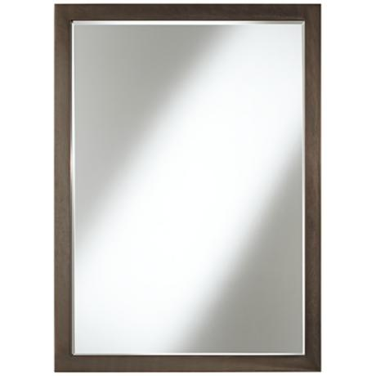 | Use a mirror that is big enough for you to see your arm, and has a clear reflection. No smudges or dust – that makes it easier to see!

Getting started | Place your weak arm inside the box or with the mirror facing your strong arm.
 | Make sure the mirror is placed in front of you so you can easily see the reflection of your strong arm clearly in the mirror.
 | Start by looking directly at the mirror image of your strong hand. Try to imagine that you are really seeing your other hand. This may take a minute or two, but sometimes happens quite quickly.
Then try gently doing the exercises your therapist has given you with your strong hand only. Try to focus on the image in the mirror while you do the movements.

You want to imagine that your weak hand is doing the same movements as your strong hand.

You should try and do different movements, making them slow and smooth. Try to work like this for ______ minutes.

Keep going! | Now repeat the same exercises, but this time, try to do them with both hands at the same time. Keep looking at the mirror while you do the movements.  Do not do anything that produces pain. Stop if you feel tired or dizzy. Try to work like this for __________ minutes.

